Experiment 13

Name: Shubham Mourya SAP ID: 60017230110

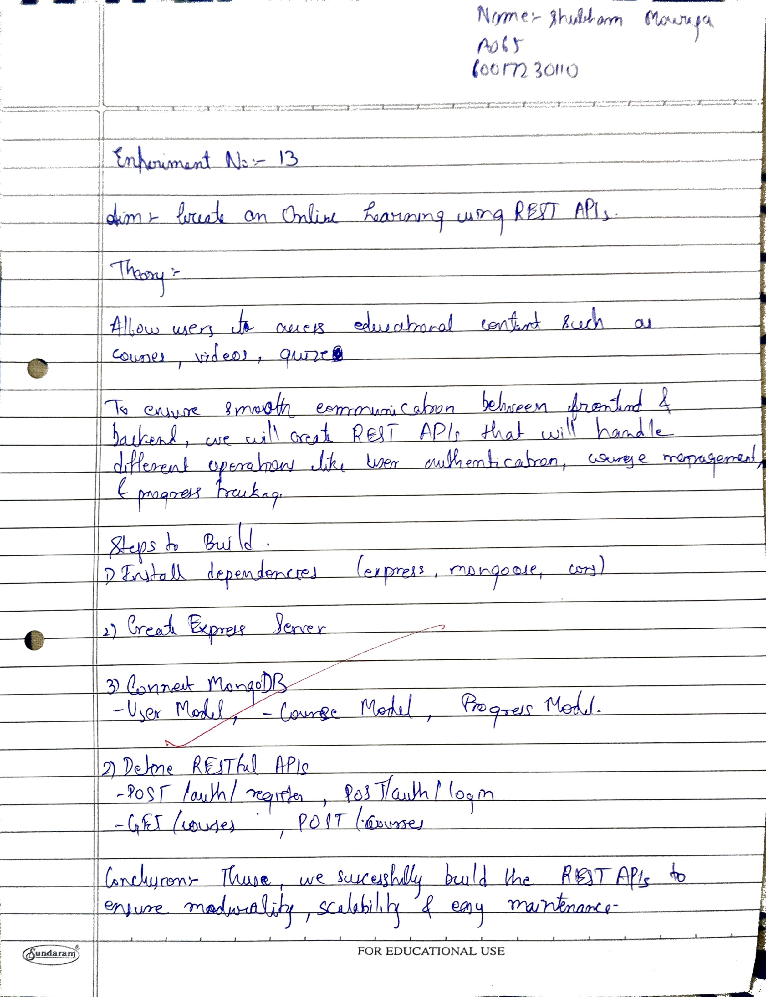

|  |  |
| --- | --- |
| Aim | **Create an Online Learning application using REST APIs** |
| Software | VS Code |
| Pre-requisit e | Active internet connection |
| Theory | **Steps to Create an Online Learning Application using REST APIs Step 1: Set Up Your Development Environment**  To begin, ensure you have Node.js and npm installed on your system. These  tools are required to build both the backend and frontend of your application.  **Step 2: Design the Application Structure**  Create separate directories for your backend and frontend to keep the code organized. Your backend will serve as the REST API provider, and the frontend will act as the client interface for users.   * **Backend:** Contains your API routes and connects to the database. * **Frontend:** Hosts the user interface, such as registration, login, courses, and learning modules.   **Express** will handle API requests.  **Mongoose** will connect to MongoDB.  **Body-parser** will parse incoming request bodies.  **Step 4: Define Your API Endpoints**  Create an app.js file in the backend folder to define your REST API  endpoints for core functionalities like registration, login, course enrollment, and progress tracking:  **Step 5: Connect to MongoDB and Define Schemas**  Use MongoDB to store user data and course information. Define schemas for users, courses, and enrollments in a models folder within the backend directory:  Follow a similar structure for defining course and enrollment schemas.  Step 6: Implement User Authentication  Add user authentication with JSON Web Token (JWT) to secure access. Install the jsonwebtoken package:  Create routes for registration, login, and token verification to ensure only authenticated users can access certain endpoints. |

|  |  |
| --- | --- |
|  | **Step 7: Develop the Frontend**  In the frontend folder, create a React app using the following command: Install Axios for API calls:  Design the UI for features like login, viewing courses, and tracking learning progress. Use Axios to fetch data from your backend API.  Once set up, start by building the main pages and components:   1. **Login and Registration Pages**: Forms for user authentication, allowing new users to register and existing users to log in. 2. **Course List Page**: Displays a list of available courses. Users can browse and select courses to enroll in. 3. **Course Detail Page**: Shows details about a specific course, including modules, instructor info, and course requirements. 4. **User Dashboard**: A personalized area for each user to track enrolled courses, view progress, and access completed materials.   Use React's state and props to manage data flow between components. With react-router-dom, set up routes for each page to provide a smooth navigation experience:  **Step 8: Integrate REST APIs with Frontend**  After building the UI components, connect them to your backend REST APIs. In the src directory, create an api.js file to centralize all Axios requests to streamline API interactions and handle responses in a single place:  **Step 9: Test and Deploy Your Application**  Test the API endpoints and ensure the frontend displays data as expected. Deploy your backend and frontend using services like Heroku for backend APIs and Netlify for frontend.  For deployment:   * **Backend**: Host the backend on platforms like Heroku or Render.   Ensure your environment variables (e.g., MongoDB URI, JWT secret) are securely configured on the server.   * **Frontend**: Deploy the React frontend to services like Netlify or   Vercel. Update the backend API URL to the production server URL in your frontend code.  By following these steps, you can create a functional online learning  application that allows user registration, course enrollment, and tracking of learning progress. |
| Code | Frontend  AllCourses.jsx |

|  |  |
| --- | --- |
|  | import React from 'react';  import {Link} from 'react-router-dom'; import {useEffect, useState} from 'react'; import axios from 'axios';  const baseURL = 'http://127.0.0.1:8000/api/course/'; function AllCourses() {  const [courseData, setCourseData] = useState([]); useEffect(() => {  axios.get(baseURL).then((res) => { setCourseData(res.data);  // console.log('data is ', res.data);  });  }, []);  return (  <div className="container mt-4">  <div className="row border-bottom border-primary pb-1 mb-1">  <h3 className="col">Latest Courses</h3>  <a className="col text-uppercase fw-bold" href="#1">  <Link to={'/'}>Go Back</Link>  </a>  </div>  <div className="row mb-4">  {courseData && courseData.map((data, index) => { return (  <div className="col-md-3">  <div className="card">  <Link to="/detail/1">  {' '}  <img src={data.featured_img}  className="card-img-top w-40" alt="..."  />  </Link>  <div className="card-body d-flex flex-column">  <h5 className="card-title">  <Link to="/detail/1">{data.title}</Link>  </h5>  <p className="card-text">{data.description}</p>  <Link to={`/detail/${courseData.id}`}>  <a href="#1" className="btn btn-primary"> Course Detail  </a>  </Link>  <div className="card-footer"> |

|  |  |
| --- | --- |
|  | <div className="title">  <span>Rating: 4.6/5</span>  <span className="float-end">Views: 5451</span>  </div>  </div>  </div>  </div>  </div>  );  })}  </div>  </div>  );  }  export default AllCourses;  CategoryCourses.jsx:  import React from 'react';  import {Link} from 'react-router-dom';  function CategoryCourses() { return (  <div className="container mt-4">  <div className="row border-bottom border-primary pb-1 mb-1">  <h3 className="col">Web development courses</h3>  <a className="col text-uppercase fw-bold" href="#1">  <Link to={'/'}>Go Back</Link>  </a>  </div>  <div className="row mb-4">  <div className="col-md-3">  <div className="card">  <Link to="/detail/1">  {' '}  <img  [src="https://www.ptuk.edu.ps/projects/edu4all/wp-content/uploads/20](http://www.ptuk.edu.ps/projects/edu4all/wp-content/uploads/20) 21/02/cropped-Edu-4-all-Final-Jan-2021-01-1.png"  className="card-img-top rounded-circle" alt="..."  />  </Link>  <div className="card-body d-flex flex-column">  <h5 className="card-title">  <Link to="/detail/1">Card title</Link> |

|  |  |
| --- | --- |
|  | </h5>  <p className="card-text">  Some quick example text to build on the card title and  make up  the bulk of the card's content.  </p>  <a href="#1" className="btn btn-primary"> Go somewhere  </a>  </div>  </div>  </div>  <div className="col-md-3">  <div className="card">  <Link to="/detail/1">  {' '}  <img  [src="https://www.ptuk.edu.ps/projects/edu4all/wp-content/uploads/20](http://www.ptuk.edu.ps/projects/edu4all/wp-content/uploads/20) 21/02/cropped-Edu-4-all-Final-Jan-2021-01-1.png"  className="card-img-top rounded-circle" alt="..."  />  </Link>  <div className="card-body d-flex flex-column">  <h5 className="card-title">  <Link to="/detail/1">Card title</Link>  </h5>  <p className="card-text">  Some quick example text to build on the card title and  make up  the bulk of the card's content.  </p>  <a href="#1" className="btn btn-primary"> Go somewhere  </a>  </div>  </div>  </div>{' '}  <div className="col-md-3">  <div className="card">  <Link to="/detail/1">  {' '}  <img  the bulk of the card's content.  </p>  <a href="#1" className="btn btn-primary"> |

|  |  |
| --- | --- |
|  | Go somewhere  </a>  </div>  </div>  </div>{' '}  <div className="col-md-3">  <div className="card">  <Link to="/detail/1">  {' '}  <img  [src="https://www.ptuk.edu.ps/projects/edu4all/wp-content/uploads/20](http://www.ptuk.edu.ps/projects/edu4all/wp-content/uploads/20) 21/02/cropped-Edu-4-all-Final-Jan-2021-01-1.png"  className="card-img-top rounded-circle" alt="..."  />  </Link>  <div className="card-body d-flex flex-column">  <h5 className="card-title">  <Link to="/detail/1">Card title</Link>  </h5>  <p className="card-text">  Some quick example text to build on the card title and  make up  the bulk of the card's content.  </p>  <a href="#1" className="btn btn-primary"> Go somewhere  </a>  </div>  </div>  </div>{' '}  <div className="col-md-3">  <div className="card">  <Link to="/detail/1">  {' '}  <img  [src="https://www.ptuk.edu.ps/projects/edu4all/wp-content/uploads/20](http://www.ptuk.edu.ps/projects/edu4all/wp-content/uploads/20) 21/02/cropped-Edu-4-all-Final-Jan-2021-01-1.png"  className="card-img-top rounded-circle" alt="..."  />  </Link>  <div className="card-body d-flex flex-column">  <h5 className="card-title">  <Link to="/detail/1">Card title</Link> |

|  |  |
| --- | --- |
|  | </h5>  <p className="card-text">  Some quick example text to build on the card title and  make up  the bulk of the card's content.  </p>  <a href="#1" className="btn btn-primary"> Go somewhere  </a>  </div>  </div>  </div>{' '}  <div className="col-md-3">  <div className="card">  <Link to="/detail/1">  {' '}  <img  [src="https://www.ptuk.edu.ps/projects/edu4all/wp-content/uploads/20](http://www.ptuk.edu.ps/projects/edu4all/wp-content/uploads/20) 21/02/cropped-Edu-4-all-Final-Jan-2021-01-1.png"  className="card-img-top rounded-circle" alt="..."  />  </Link>  <div className="card-body d-flex flex-column">  <h5 className="card-title">  <Link to="/detail/1">Card title</Link>  </h5>  <p className="card-text">  Some quick example text to build on the card title and  make up  the bulk of the card's content.  </p>  <a href="#1" className="btn btn-primary"> Go somewhere  </a>  </div>  </div>  </div>{' '}  <div className="col-md-3">  <div className="card">  <Link to="/detail/1">  {' '}  <img  [src="https://www.ptuk.edu.ps/projects/edu4all/wp-content/uploads/20](http://www.ptuk.edu.ps/projects/edu4all/wp-content/uploads/20) 21/02/cropped-Edu-4-all-Final-Jan-2021-01-1.png" |

|  |  |
| --- | --- |
|  | className="card-img-top rounded-circle" alt="..."  />  </Link>  <div className="card-body d-flex flex-column">  <h5 className="card-title">  <Link to="/detail/1">Card title</Link>  </h5>  <p className="card-text">  Some quick example text to build on the card title and  make up  the bulk of the card's content.  </p>  <a href="#1" className="btn btn-primary"> Go somewhere  </a>  </div>  </div>  </div>{' '}  <div className="col-md-3">  <div className="card">  <Link to="/detail/1">  {' '}  <img  [src="https://www.ptuk.edu.ps/projects/edu4all/wp-content/uploads/20](http://www.ptuk.edu.ps/projects/edu4all/wp-content/uploads/20) 21/02/cropped-Edu-4-all-Final-Jan-2021-01-1.png"  className="card-img-top rounded-circle" alt="..."  />  </Link>  <div className="card-body d-flex flex-column">  <h5 className="card-title">  <Link to="/detail/1">Card title</Link>  </h5>  <p className="card-text">  Some quick example text to build on the card title and  make up  the bulk of the card's content.  </p>  <a href="#1" className="btn btn-primary"> Go somewhere  </a>  </div>  </div>  </div>{' '}  <div className="col-md-3"> |

|  |  |
| --- | --- |
|  | <div className="card">  <Link to="/detail/1">  {' '}  <img l/1">Card title</Link>  </h5>  <p className="card-text">  Some quick example text to build on the card title and  make up  the bulk of the card's content.  </p>  <a href="#1" className="btn btn-primary"> Go somewhere  </a>  </div>  </div>  </div>{' '}  <div className="col-md-3">  <div className="card">  <Link to="/detail/1">  {' '}  <img  [src="https://www.ptuk.edu.ps/projects/edu4all/wp-content/uploads/20](http://www.ptuk.edu.ps/projects/edu4all/wp-content/uploads/20) 21/02/cropped-Edu-4-all-Final-Jan-2021-01-1.png"  className="card-img-top rounded-circle" alt="..."  />  </Link>  <div className="card-body d-flex flex-column">  <h5 className="card-title">  <Link to="/detail/1">Card title</Link>  </h5>  <p className="card-text">  Some quick example text to build on the card title and  make up  the bulk of the card's content.  </p>  <a href="#1" className="btn btn-primary"> Go somewhere  </a>  </div>  </div>  </div>{' '}  <div className="col-md-3">  <div className="card">  <Link to="/detail/1"> |

|  |  |
| --- | --- |
|  | {' '}  <img  [src="https://www.ptuk.edu.ps/projects/edu4all/wp-content/uploads/20](http://www.ptuk.edu.ps/projects/edu4all/wp-content/uploads/20) 21/02/cropped-Edu-4-all-Final-Jan-2021-01-1.png"  className="card-img-top rounded-circle" alt="..."  />  </Link>  <div className="card-body d-flex flex-column">  <h5 className="card-title">  <Link to="/detail/1">Card title</Link>  </h5>  <p className="card-text">  Some quick example text to build on the card title and  make up  the bulk of the card's content.  </p>  <a href="#1" className="btn btn-primary"> Go somewhere  </a>  </div>  </div>  </div>{' '}  <div className="col-md-3">  <div className="card">  <Link to="/detail/1">  {' '}  <img  [src="https://www.ptuk.edu.ps/projects/edu4all/wp-content/uploads/20](http://www.ptuk.edu.ps/projects/edu4all/wp-content/uploads/20) 21/02/cropped-Edu-4-all-Final-Jan-2021-01-1.png"  className="card-img-top rounded-circle" alt="..."  />  </Link>  <div className="card-body d-flex flex-column">  <h5 className="card-title">  <Link to="/detail/1">Card title</Link>  </h5>  <p className="card-text">  Some quick example text to build on the card title and  make up  the bulk of the card's content.  </p>  <a href="#1" className="btn btn-primary"> Go somewhere |

|  |  |
| --- | --- |
|  | </a>  </div>  </div>  </div>{' '}  <div className="col-md-3">  <div className="card">  <Link to="/detail/1">  {' '}  <img  [src="https://www.ptuk.edu.ps/projects/edu4all/wp-content/uploads/20](http://www.ptuk.edu.ps/projects/edu4all/wp-content/uploads/20) 21/02/cropped-Edu-4-all-Final-Jan-2021-01-1.png"  className="card-img-top rounded-circle" alt="..."  />  </Link>  <div className="card-body d-flex flex-column">  <h5 className="card-title">  <Link to="/detail/1">Card title</Link>  </h5>  <p className="card-text">  Some quick example text to build on the card title and  make up  the bulk of the card's content.  </p>  <a href="#1" className="btn btn-primary"> Go somewhere  </a>  </div>  </div>  </div>{' '}  <div className="col-md-3">  <div className="card">  <Link to="/detail/1">  {' '}  <img  [src="https://www.ptuk.edu.ps/projects/edu4all/wp-content/uploads/20](http://www.ptuk.edu.ps/projects/edu4all/wp-content/uploads/20) 21/02/cropped-Edu-4-all-Final-Jan-2021-01-1.png"  className="card-img-top rounded-circle" alt="..."  />  </Link>  <div className="card-body d-flex flex-column">  <h5 className="card-title">  <Link to="/detail/1">Card title</Link>  </h5> |

|  |  |
| --- | --- |
|  | <p className="card-text">  </Link>  <div className="card-body d-flex flex-column">  <h5 className="card-title">  <Link to="/detail/1">Card title</Link>  </h5>  <p className="card-text">  Some quick example text to build on the card title and  make up  the bulk of the card's content.  </p>  <a href="#1" className="btn btn-primary"> Go somewhere  </a>  </div>  </div>  </div>  <div className="col-md-3">  <div className="card">  <img  [src="https://www.ptuk.edu.ps/projects/edu4all/wp-content/uploads/20](http://www.ptuk.edu.ps/projects/edu4all/wp-content/uploads/20) 21/02/cropped-Edu-4-all-Final-Jan-2021-01-1.png"  className="card-img-top rounded-circle" alt="..."  />  <div className="card-body d-flex flex-column">  <h5 className="card-title">Card title</h5>  <p className="card-text">  Some quick example text to build on the card title and  make up  the bulk of the card's content.  </p>  <a href="#1" className="btn btn-primary"> Go somewhere  </a>  </div>  </div>  </div>{' '}  <div className="col-md-3">  <div className="card">  <img  [src="https://www.ptuk.edu.ps/projects/edu4all/wp-content/uploads/20](http://www.ptuk.edu.ps/projects/edu4all/wp-content/uploads/20) 21/02/cropped-Edu-4-all-Final-Jan-2021-01-1.png"  className="card-img-top rounded-circle" alt="..." |

|  |  |
| --- | --- |
|  | />  <div className="card-body d-flex flex-column">  <h5 className="card-title">Card title</h5>  <p className="card-text">  Some quick example text to build on the card title and  make up  the bulk of the card's content.  </p>  <a href="#1" className="btn btn-primary"> Go somewhere  </a>  </div>  </div>  </div>{' '}  <div className="col-md-3">  <div className="card">  <img  [src="https://www.ptuk.edu.ps/projects/edu4all/wp-content/uploads/20](http://www.ptuk.edu.ps/projects/edu4all/wp-content/uploads/20) 21/02/cropped-Edu-4-all-Final-Jan-2021-01-1.png"  className="card-img-top rounded-circle" alt="..."  />  <div className="card-body d-flex flex-column">  <h5 className="card-title">Card title</h5>  <p className="card-text">  Some quick example text to build on the card title and  make up  the bulk of the card's content.  </p>  <a href="#1" className="btn btn-primary"> Go somewhere  </a>  </div>  </div>  </div>  </div>  </div>  );  }  export default CategoryCourses; Backend:  Manage.py #!/usr/bin/env python  """Django's command-line utility for administrative tasks.""" |

|  |  |
| --- | --- |
|  | import os import sys  def main():  """Run administrative tasks.""" os.environ.setdefault('DJANGO_SETTINGS_MODULE',  'lms_api.settings') try:  from django.core.management import execute_from_command_line  except ImportError as exc: raise ImportError(  "Couldn't import Django. Are you sure it's installed and " "available on your PYTHONPATH environment variable? Did  you "  "forget to activate a virtual environment?"  ) from exc execute_from_command_line(sys.argv)  if name == ' main ': main() |
| Result |  |

|  |  |
| --- | --- |
|  |  |

|  |  |
| --- | --- |
|  |  |

|  |  |
| --- | --- |
|  |  |
| Conclusion | **Thus we have successfully created an Online Learning application using REST APIs** |